

Southern Luzon State University
COLLEGE OF ENGINEERING
Computer Engineering Department
Lucban, Quezon

CPE22L: Digital Signal Processing Laboratory

Activity # 6: Convolution

PADUADA, Dave Jhared G.

DOP: Oct 22, 2025
DOS: Oct 29, 2025

RATING

Engr. Ralph Monsour Delima
INSTRUCTOR

- Objectives
  - To understand the process of convolution
  - To determine the different types of convolutions
  - To be familiarized with the MATLAB codes used to generate output codes for convolution.
- Introductory Information

Convolution is a formal mathematical operation, just as multiplication, addition, and integration. Addition takes two numbers and produces a third number, while convolution takes two signals and produces a third signal. Convolution is used in the mathematics of many fields, such as probability and statistics. In linear systems, convolution is used to describe the relationship between three signals of interest: the input signal, the impulse response, and the output signal

- Data & Procedures

Figure 1 shows the notation when convolution is used with linear systems. An input signal, x[n], enters a linear system with an impulse response, h[n], resulting in an output signal, y[n]. In equation form: x[n] t h[n] ' y[n]. Expressed in words, the input signal convolved with the impulse response is equal to the output signal. Just as addition is represented by the plus, +, and multiplication by the cross, ×, convolution is represented by the star, t. It is unfortunate that most programming languages also use the star to indicate multiplication. A star in a computer program means multiplication, while a star in an equation means convolution.
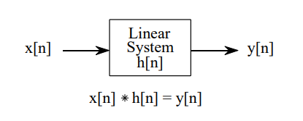
Figure 1
Figure 1 shows wow convolution is used in DSP. The output signal from a linear system is equal to the input signal convolved with the system's impulse response. Convolution is denoted by a star when writing equations.

PROGRAM 6_1  clc;  clear all;  close all;  %Program to perform Linear Convolution  x1=input('Enter the first sequence to be convoluted:');  x2=input('Enter the second sequence to be convoluted:');  subplot(3,1,1);  stem(x1);  xlabel('Time');  ylabel('Amplitude');  title('First sequence');  subplot(3,1,2);  stem(x2);  xlabel('Time');  ylabel('Amplitude');  title('Second sequence');  f=conv(x1,x2);  disp('The Linear convoluted sequence is');  disp(f);  subplot(3,1,3);  stem(f);  xlabel('Time');  ylabel('Amplitude');  title('Linear Convoluted sequence'); | PROGRAM6_2  clc;  clear all;  close all;  %Program to perform Linear Convolution  x=input('Enter the first input sequence:');  h=input('Enter the system response sequence:');  l1=length(x);  subplot(3,2,1);  stem(x);  xlabel('Time index--->');  ylabel('Amplitude');  title('input sequence');  l2=length(h);  subplot(3,2,2);  stem(h);  xlabel('Time');  ylabel('Amplitude');  title('system response sequence');  if l1>l2  l3=l1-l2;  h=[h,zeros(1,l3)];  elseif l2>l1;  l3=l2-l1;  x=[x,zeros(1,l3)];  end  y=conv(x,h);  disp('The time convoluted convoluted sequence is');  disp(y);  subplot(3,2,3);  stem(y);  xlabel('Time index--->');  ylabel('Amplitude');  title('convoluted output sequence');  X=fft(x,length(y));  H=fft(h,length(y));  Y=X.*H;  disp('The frequency domain multiplied sequence is:');  disp(Y);  subplot(3,2,4);  stem(Y);  xlabel('Time index--->');  ylabel('Amplitude');  title('frequency domain multiplied response');  y1=ifft(Y,length(Y));  disp('The inverse fourier transformed sequence is:')  disp(y1);  subplot(3,2,5);  stem(y1);  xlabel('Time index--->');  ylabel('Amplitude');  title('output after inverse fourier transform');  e=y-y1;  disp('The Error sequence:');  disp(abs(e));  subplot(3,2,6);  stem(abs(e));  xlabel('Time index--->');  ylabel('Amplitude');  title('error sequence');
PROGRAM 6_3  clc;  clc;  clear all;  close all;  %Program to perform Circular Convolution  x1=input('Enter the first sequence to be convoluted:');  x2=input('Enter the second sequence to be convoluted:');  subplot(3,1,1);  l1=length(x1);  stem(x1);  xlabel('Time');  ylabel('Amplitude');  title('First sequence');  subplot(3,1,2);  l2=length(x2);  stem(x2);  xlabel('Time');  ylabel('Amplitude');  title('Second sequence');  if l1>l2  l3=l1-l2;  x2=[x2,zeros(1,l3)];  elseif l2>l1;  l3=l2-l1;  x1=[x1,zeros(1,l3)];  end  f=cconv(x1,x2);  disp('The Circular convoluted sequence is');  disp(f);  subplot(3,1,3);  stem(f);  xlabel('Time');  ylabel('Amplitude');  title('Circular Convoluted sequence');  Q6.3 Run Program P6_3 to perform circular convolution and discuss the result. | PROGRAM6_4  clc;  clear all;  close all;  %Program to perform Linear Convolution using Circular Convolution  x1=input('Enter the first sequence to be convoluted:');  x2=input('Enter the second sequence to be convoluted:');  l1=length(x1);  subplot(3,1,1);  stem(x1);  xlabel('Time index');  ylabel('Amplitude');  title('First sequence');  l2=length(x2);  subplot(3,1,2);  stem(x2);  xlabel('Time');  ylabel('Amplitude');  title('Second sequence');  if l1>l2  l3=l1-l2;  x2=[x2,zeros(1,l3)];  elseif l2>l1;  l3=l2-l1;  x1=[x1,zeros(1,l3)];  end  n=l1+l2-1;  f=cconv(x1,x2,n);  disp('The convoluted convoluted sequence is');  disp(f);  subplot(3,1,3);  stem(f);  xlabel('Time index');  ylabel('Amplitude');  title('Convoluted sequence');  Q6.4 Run Program P6_4 to perform Linear Convolution using Circular Convolution and discuss the result.
PROGRAM 6_5
clc;
clear all;
close all;
%Program for Circular convolution using discrete convolution expression

x=input('Enter the first sequence:');
n1=length(x);
h=input('Enter the second sequence:');
n2=length(h);
n=0:1:n1-1;
subplot(3,1,1);
stem(n,x);
xlabel('Time');
ylabel('Amplitude');
title('First sequence Response x[n]');
n=0:1:n2-1;
subplot(3,1,2);
stem(n,h);
xlabel('Time');
ylabel('Amplitude');
title('Second sequence Response x[n]');
n=n1+n2-1;
if n1>n2
n3=n1-n2;
h=[h,zeros(1,n3)];
elseif n2>n1;
n3=n2-n1;
x=[x,zeros(1,n3)];
end
x=[x,zeros(1,n-n1)];
h=[h,zeros(1,n-n2)];
for n=1:n;
y(n)=0;
for i=1:n
j=n-i+1;
if(j<=0)
j=n+j;
end
y(n)=y(n)+x(i)*h(j);
end
end
disp('Circular convolution of x & h is');
disp(y);
subplot(3,1,3);
stem(y);
xlabel('Time');
ylabel('Amplitude');
title('Circular Convoluted Sequence Response');

- Data and Results
Q6.1 Run Program P6_1 to perform linear convolution and discuss the result. | 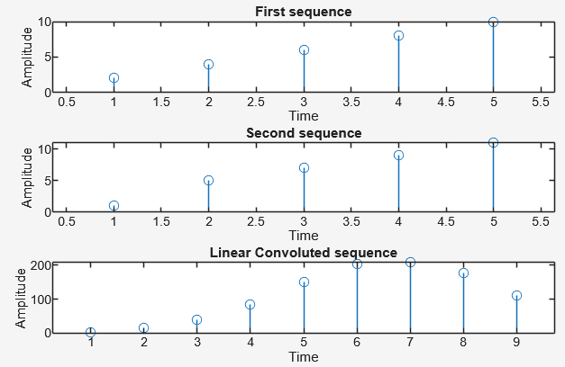  Enter the first sequence to be convoluted:[2, 4, 6, 8, 10]  Enter the second sequence to be convoluted:[1, 5, 7, 9, 11]  The Linear convoluted sequence is  2 14 40 84 150 204 208 178 110  Program P6_1 performs linear convolution between two discrete-time sequences using MATLAB’s conv() function. The output sequence shows how one signal is modified by the other, with the result having a length equal to the sum of both sequences minus one. The plot confirms the combined effect of the two input signals in the time domain.
Q6.2 Run Program P6_2 to perform linear convolution and discuss the result. | Enter the first input sequence:[1 2 3 4]  Enter the system response sequence:[1 1 1]  The time convoluted convoluted sequence is  1 3 6 9 7 4 0  The frequency domain multiplied sequence is:  30.0000 + 0.0000i -13.7702 - 5.1631i 1.2986 - 0.4934i 0.9717 - 1.6878i 0.9717 + 1.6878i 1.2986 + 0.4934i -13.7702 + 5.1631i  The inverse fourier transformed sequence is:  1.0000 3.0000 6.0000 9.0000 7.0000 4.0000 0.0000  The Error sequence:  1.0e-15 *  0 0 0.8882 0 0 0.8882 0.7613  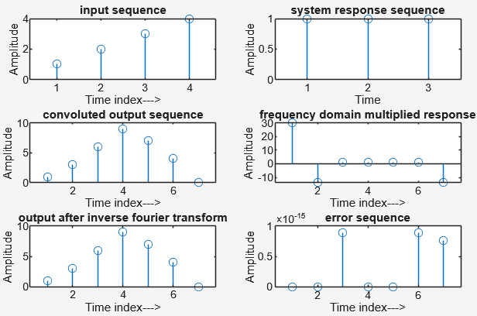  Program P6_2 verifies linear convolution using both the time-domain and frequency-domain approaches. The FFT and IFFT methods produce the same result as the direct convolution, with only a very small numerical error. This confirms the convolution theorem, which states that time-domain convolution equals frequency-domain multiplication.
Q6.3 Run Program P6_3 to perform circular convolution and discuss the result. | 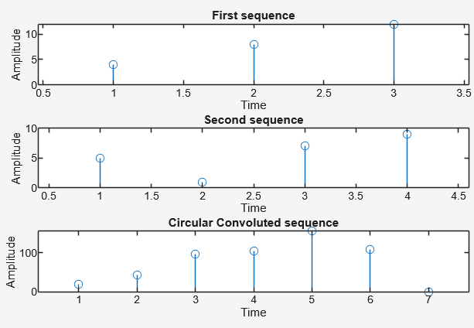  Enter the first sequence to be convoluted:[4 8 12]  Enter the second sequence to be convoluted:[5 1 7 9]  The Circular convoluted sequence is  20.0000 44.0000 96.0000 104.0000 156.0000 108.0000 0.0000  Program P6_3 performs circular convolution using MATLAB’s cconv() function. Unlike linear convolution, the result here “wraps around” because of the circular property, causing overlapping of values at the edges. The output demonstrates periodic behavior typical of circular systems.
Q6.4 Run Program P6_4 to perform Linear Convolution using Circular Convolution and discuss the result. | 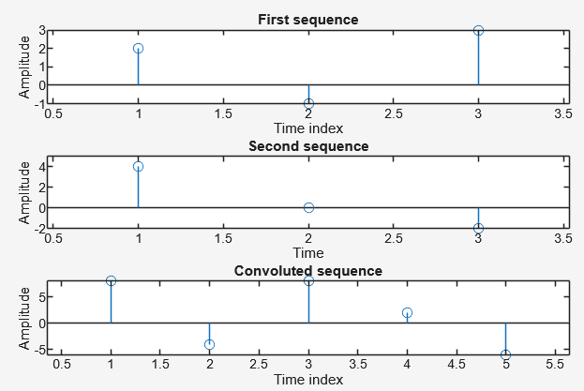  Enter the first sequence to be convoluted:[2 -1 3]  Enter the second sequence to be convoluted:[4 0 -2]  The convoluted convoluted sequence is  8.0000 -4.0000 8.0000 2.0000 -6.0000  Program P6_4 shows that linear convolution can be obtained using circular convolution when the length of the circular convolution is set to $N=L_{1}+L_{2}-1$. The result matches exactly with the direct linear convolution output. This proves that circular convolution can simulate linear convolution if proper zero-padding is applied.
Q6.5 Run Program P6_5 to perform Circular convolution using discrete convolution expression and discuss the result | Enter the first sequence:[3 -1 2 -2]  Enter the second sequence:[1 0 -1 2]  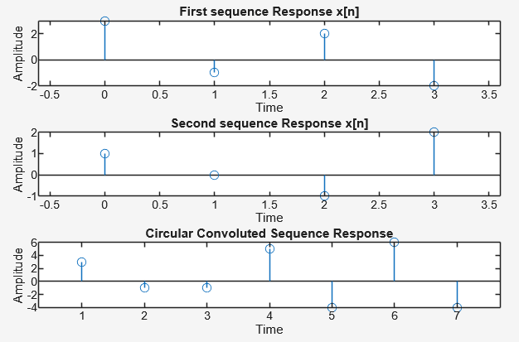  Circular convolution of x & h is  3 -1 -1 5 -4 6 -4  Program P6_5 computes circular convolution manually using the discrete convolution expression and nested loops. The output is consistent with MATLAB’s built-in cconv() function, confirming the correctness of the algorithm. This helps illustrate how circular convolution is derived mathematically through modular index operations.

- Conclusion
The set of experiments demonstrates the relationship between linear and circular convolution in discrete-time signal processing. Linear convolution shows the complete output of two sequences, while circular convolution emphasizes periodic wrapping behavior. By comparing different methods, direct, frequency-based, and formula-based, the lab confirms the theoretical equivalence and practical implementation of convolution in MATLAB.

